## Scenario

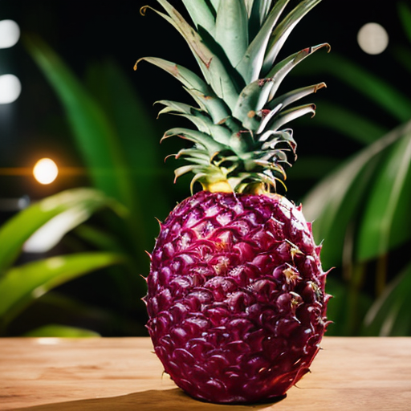

You work for Banana Boutique a specialty distributor for exotic fruit. Specifically, you work in procurement. Each year the business must plan for the upcoming year because lead times with exotic fruit growers and long and importing logistics can be complicated. You’ve been assigned the task of forecasting 12 individual fruits. You have asked the data team to pull historical sales for the last few years to perform your analysis.

## Data

Source: [This](https://www.kaggle.com/kondla/carinsurance) data is synthetic. There ar2 12 CSVs each with a time column and a sales volume column for each fruit. A unit is a carton of fruit, not individual. For example fruit 1 data represent a 20lb carton. The proceeding sales and costs data is listed at the carton data so no data processing is needed.

## Example *Abridged* Data

|  |  |
| --- | --- |
| date | Fruit_sales_1 |
| 4/1/20 | 388603 |
| 5/1/20 | 398516 |
| 6/1/20 | 416077 |
| 7/1/20 | 403873 |
| 8/1/20 | 392537 |
| 9/1/20 | 357720 |

## Cost and Revenue Table

To satisfy the deliverable you will need to calculate the cost and revenue for fruits along with the annual totals. You analysis will be used for grower negotians and cash flow forecasting in the business plan.

|  |  |  |
| --- | --- | --- |
| Fruit | Total Cost per carton | Revenue per carton |
| 1 | $9.00 | $19.00 |
| 2 | $7.50 | $16.50 |
| 3 | $14.00 | $25.00 |
| 4 | $18.75 | $23.75 |
| 5 | $12.00 | $18.25 |
| 6 | $17.25 | $34.00 |
| 7 | $8.50 | $18.00 |
| 8 | $14.50 | $27.95 |
| 9 | $6.75 | $17.50 |
| 10 | $9.50 | $21.00 |
| 11 | $11.75 | $22.00 |
| 12 | $12.50 | $13.50 |

## Assumptions

* Each time series is independent.
* No sales promotions were run historically nor will they be run in the future.
* Costs are negotiated 12 months in advance with growers and do not fluctuate.
* Costs are “landed” inclusive of all fees to growers, logistics and import duties.
* Sale prices are listed should be considered stable and will not change in the forecast period.

## Deliverables & Criteria for Success

|  |
| --- |
| **50 points: R Script constructing 12 time series.**  Code Documentation and best practices followed. |
| **35 points: PowerPoint file.**  A Powerpoint with an introduction slide, objective slide, data description, 12 slides for the times series (1 per fruit) each containing the following: plot of the time series, 1-3 sentence description of the time series (could be a title and takeaway box), and the average sales per year historically. The last slide should be a table with forecasted annual costs, revenue and totals. For example this table should be filled out:   |  |  |  |  | | --- | --- | --- | --- | | Fruit | Annual Forecasted Amount (sum of all your forecasts) | Annual Forecasted Cost (sum of all your forecasts*Cost) | Annual Forecasted Revenue (sum of all your forecasts*Revenue) | | Fruit 1 | XXXXXX | XXXXX | XXXX | | …. |  |  |  | | Fruit 12 | YYYYYY | YYYYY | YYYY | | Total | ZZZZZZ | ZZZZZ | ZZZZ | |
| **15 points: 12 individual CSV**  Submit 12 CSV with the annual forecasted amount for each fruit. |